OS LAB
Skill1
To Install Linux VM, Configure GCC, Setup Git Repository, Create Project Structure, Understand Shell Architecture, Build Initial Makefile To Analyze process abstraction, execute fork(), understand exec() family, analyze parent-child relationships, inspect process tree, practice system call tracing
1) Install Linux VM/WSL and Configure GCC a) Ubuntu installation, b) Terminal, c) Linux filesystem, d) GCC installation, e) Compiling and executing a C program
Linux Shell and Basic Commands-

- pwd

- ls
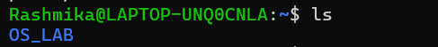
- cd
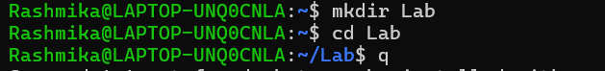

- mkdir
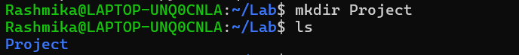
- rmdir

- cp
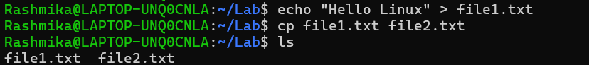
- mv
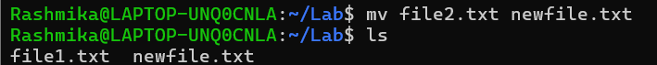

- rm
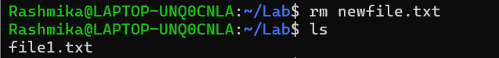

- cat

- echo

- cat

- find

- history
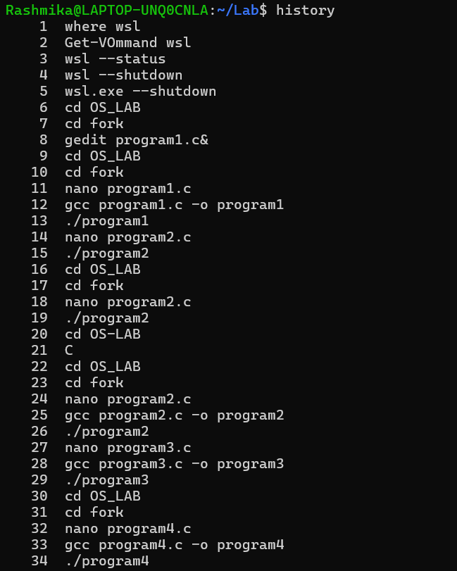
- shell usage
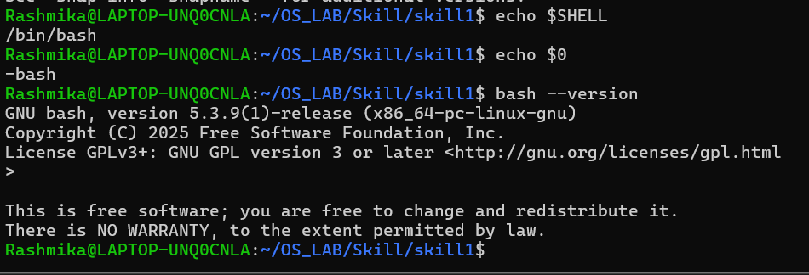
Git Repository and Project Structure - Git installation, git init, git add, git commit, git status, project directory organization (src, include, bin, docs) 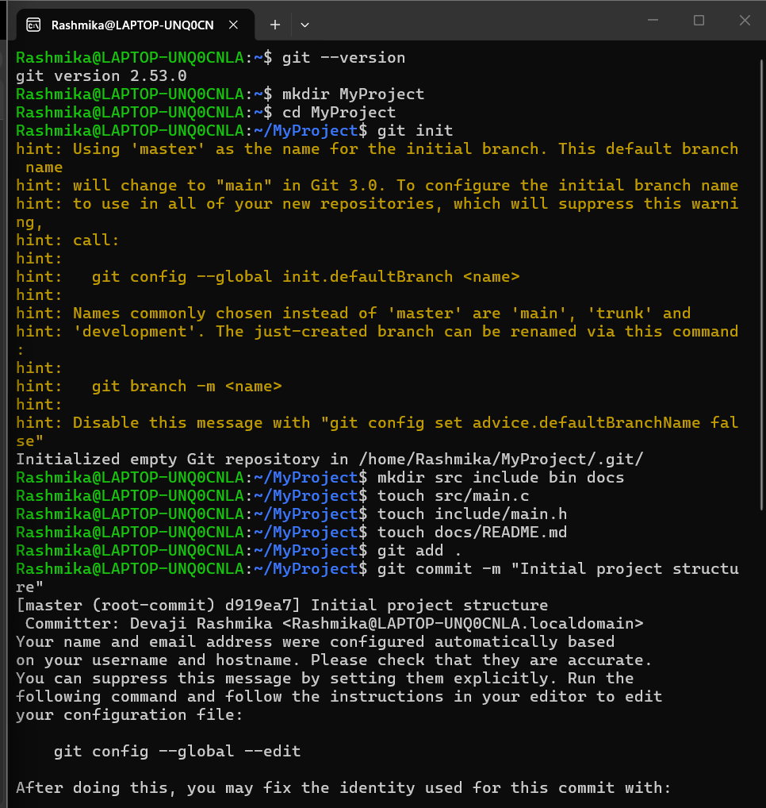
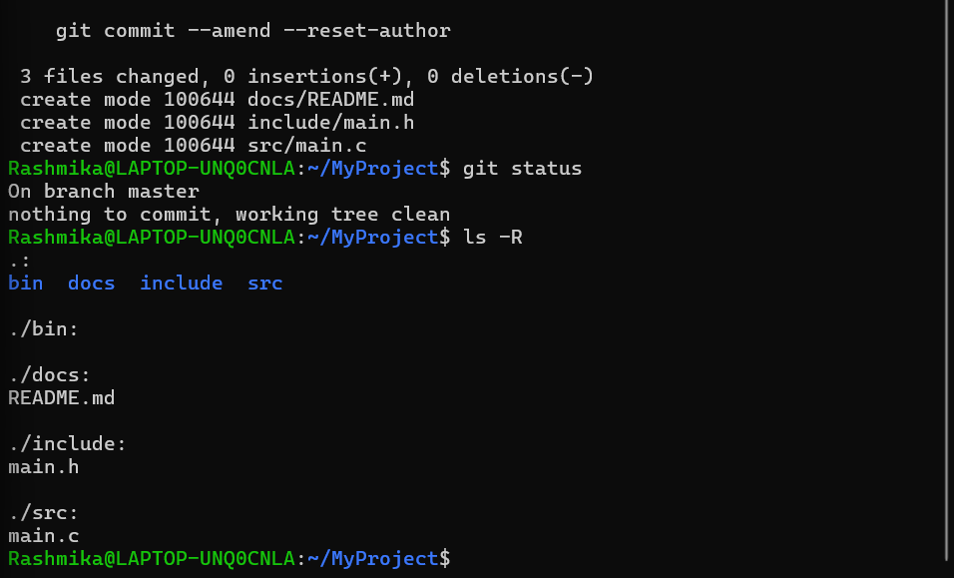

Shell Architecture and Makefile - User → Shell → Kernel → Hardware, Bash, process execution, writing a simple Makefile, using make
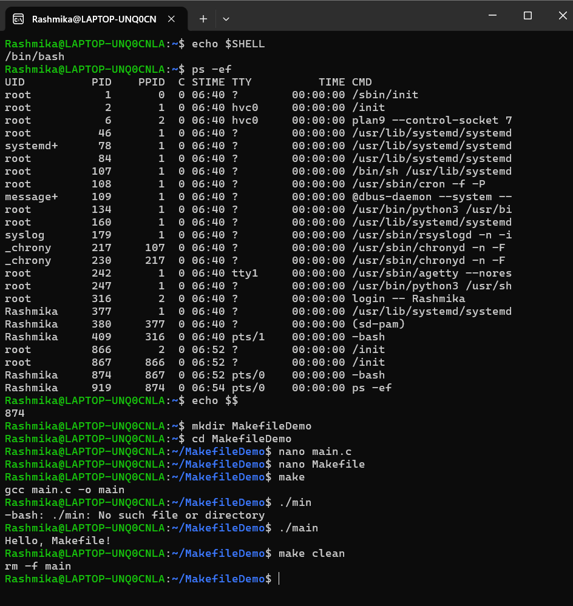

Process Creation using fork() - Process abstraction, fork(), parent and child processes, getpid(), getppid(), multiple fork() examples

#include <stdio.h>
#include <unistd.h>
#include <sys/types.h>

int main()
{
pid_t pid;

pid = fork();

if (pid < 0)
{
printf("Fork failed!\n");
}
else if (pid == 0)
{
printf("Child Process\n");
printf("Child PID : %d\n", getpid());
printf("Parent PID: %d\n", getppid());
}
else
{
printf("Parent Process\n");
printf("Parent PID : %d\n", getpid());
printf("Child PID : %d\n", pid);
}

return 0;
}
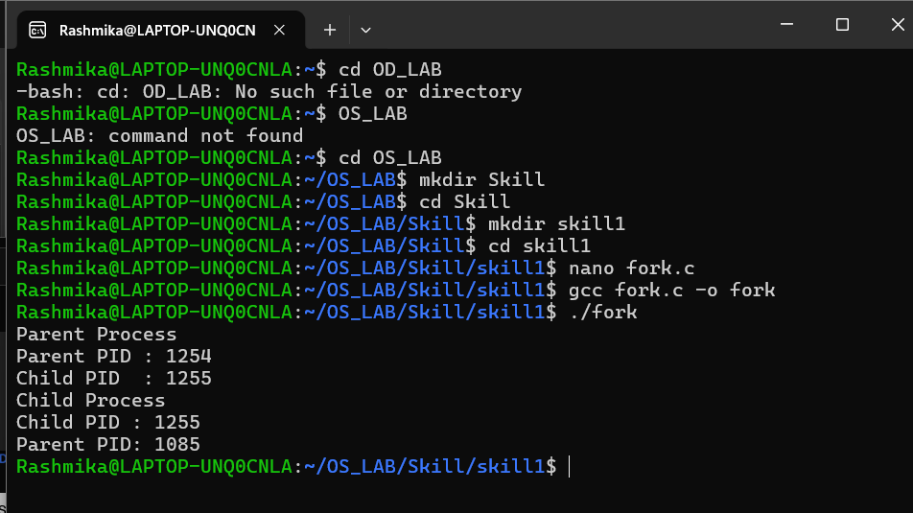

Process Replacement using the exec() Family- execl(), execv(), execvp(), replacing the current process, executing Linux commands from C

#include <stdio.h>

#include <unistd.h>

int main() {

printf("Before exec()\n");

execlp("ls", "ls", "-l", NULL);

// Only runs if exec fails

perror("exec failed");

return 1;

}

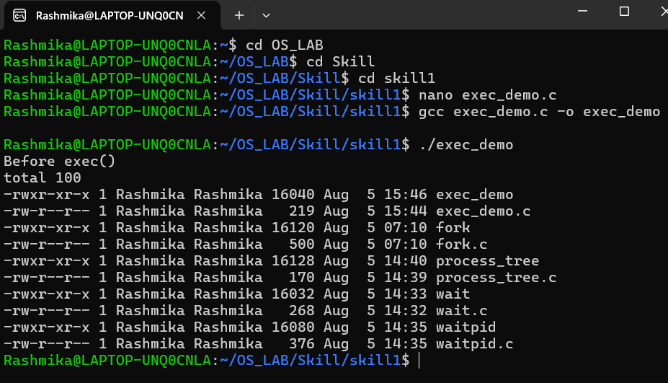

Parent–Child Synchronization using wait(), waitpid(), synchronization, process termination order

Wait.c

#include <stdio.h>
#include <unistd.h>
#include <sys/wait.h>

int main()
{
pid_t pid;

pid = fork();

if(pid == 0)
{
printf("Child Process\n");
}
else
{
wait(NULL);
printf("Parent Process\n");
}

return 0;
}

waitpid.c
#include <stdio.h>
#include <unistd.h>
#include <sys/wait.h>

int main()
{
pid_t pid;

pid = fork();

if(pid == 0)
{
printf("Child Started\n");
sleep(3);
printf("Child Finished\n");
}
else
{
printf("Parent Waiting...\n");

waitpid(pid, NULL, 0);

printf("Parent Continues\n");
}

return 0;}
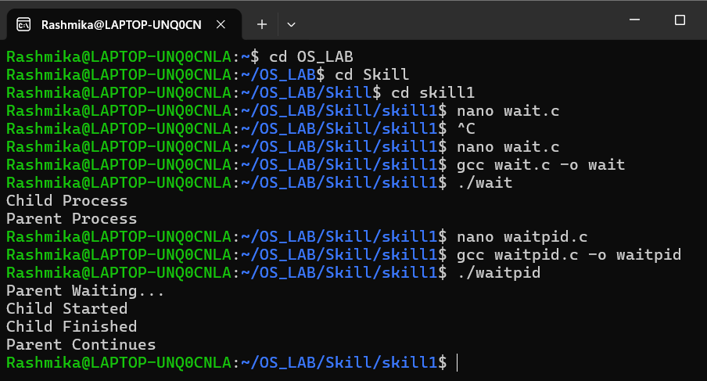

Process Tree Analysis- Multiple fork() calls, process hierarchy, pstree, ps, process IDs

#include <stdio.h>
#include <unistd.h>
#include <sys/wait.h>

int main()
{
pid_t p1, p2;

printf("Original Parent: PID = %d, PPID = %d\n", getpid(), getppid());

p1 = fork();

if (p1 == 0)
{
printf("Child 1: PID = %d, PPID = %d\n", getpid(), getppid());

p2 = fork();

if (p2 == 0)
{
printf("Grandchild: PID = %d, PPID = %d\n",
getpid(), getppid());
}
else
{
wait(NULL);
}
}
else
{
p2 = fork();

if (p2 == 0)
{
printf("Child 2: PID = %d, PPID = %d\n",
getpid(), getppid();
}
else
{
wait(NULL);
wait(NULL);
}
}

return 0;
}
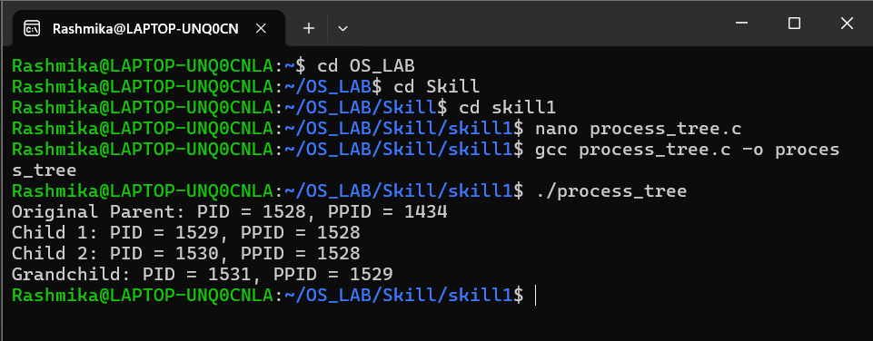

9. System Call Tracing - strace, tracing ls, pwd, date, observing execve(), open(), read(), write(), close()

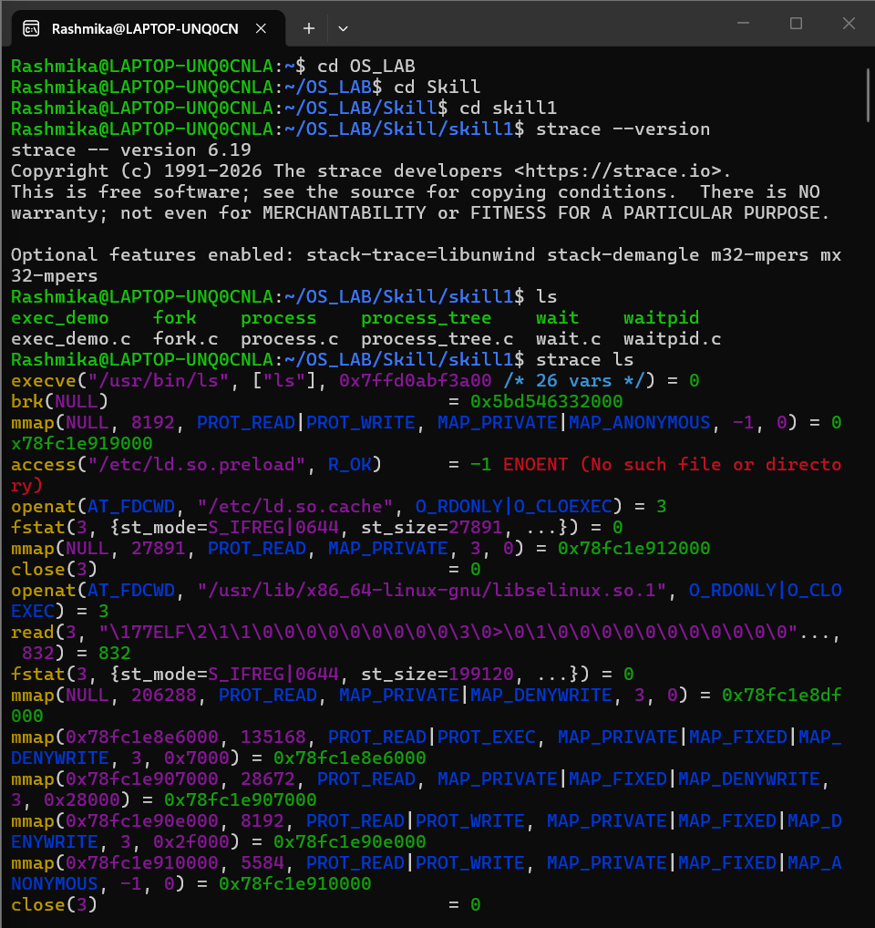
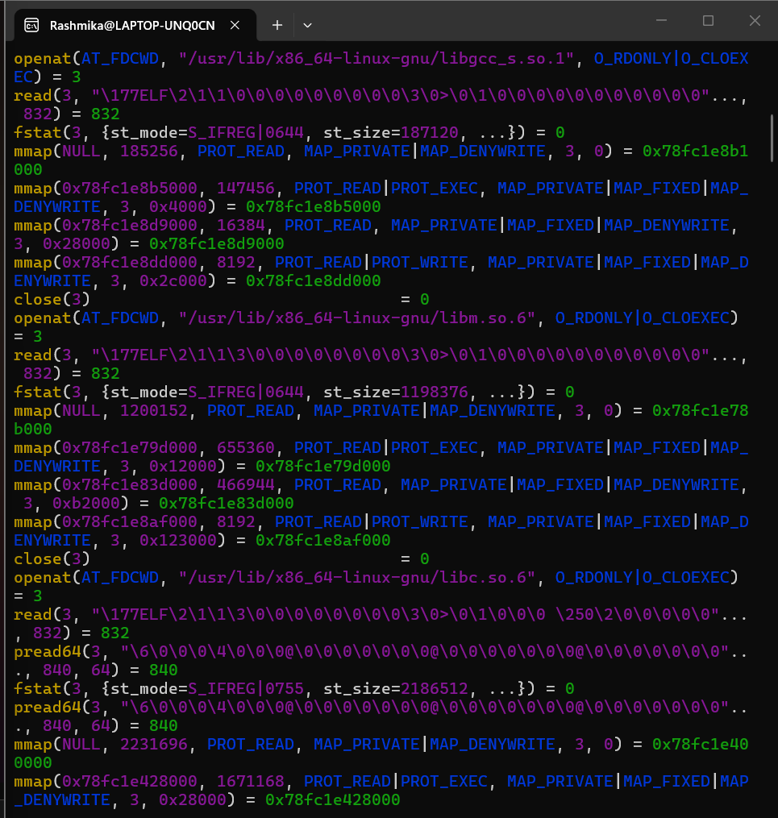
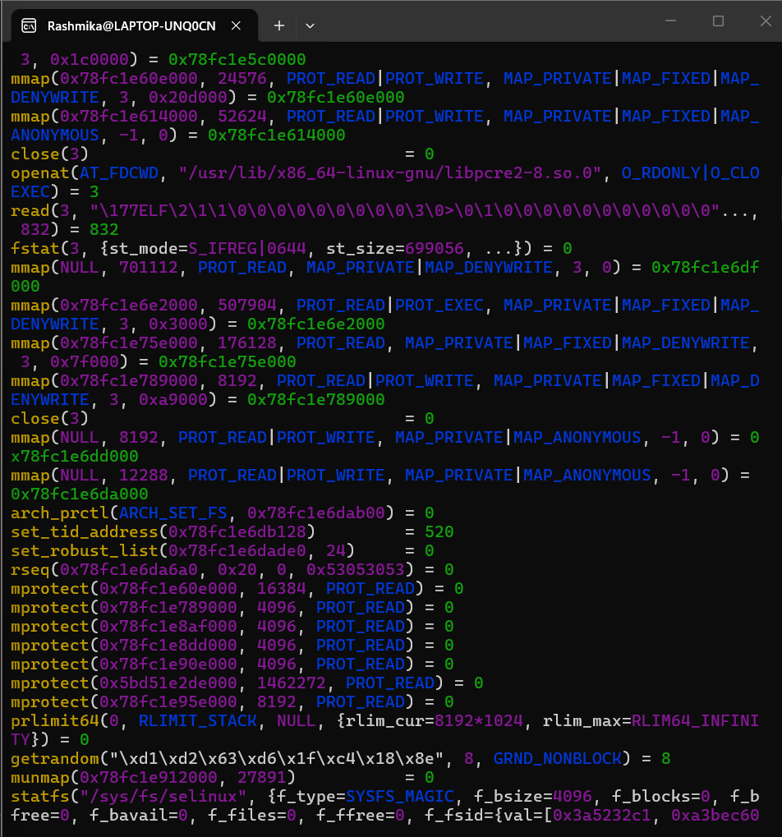
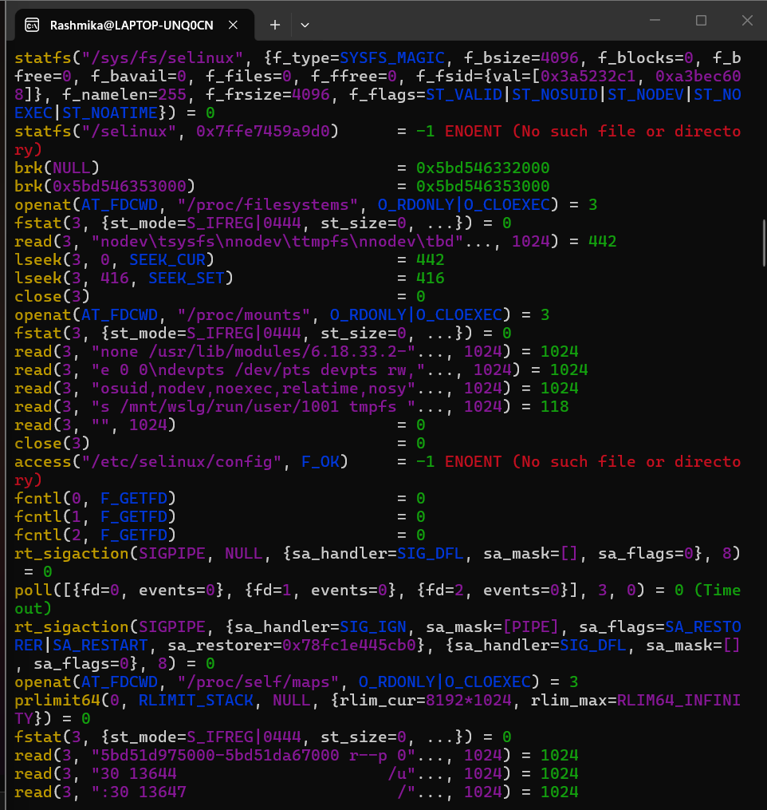
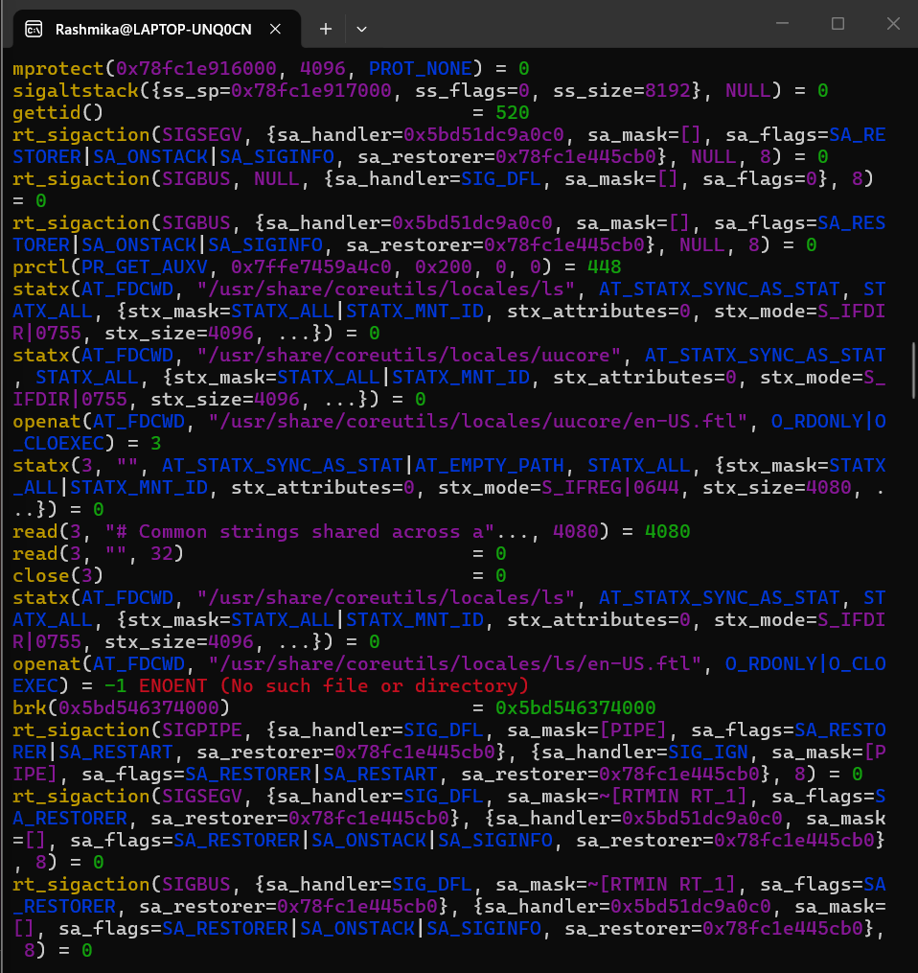
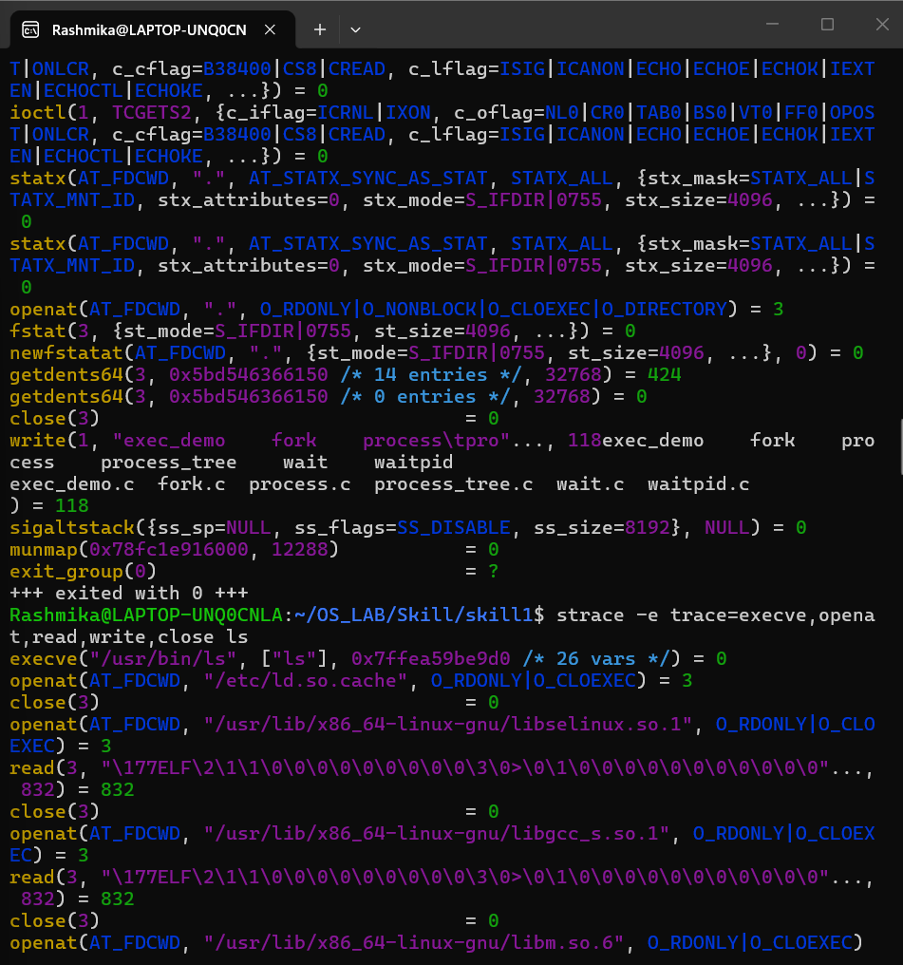

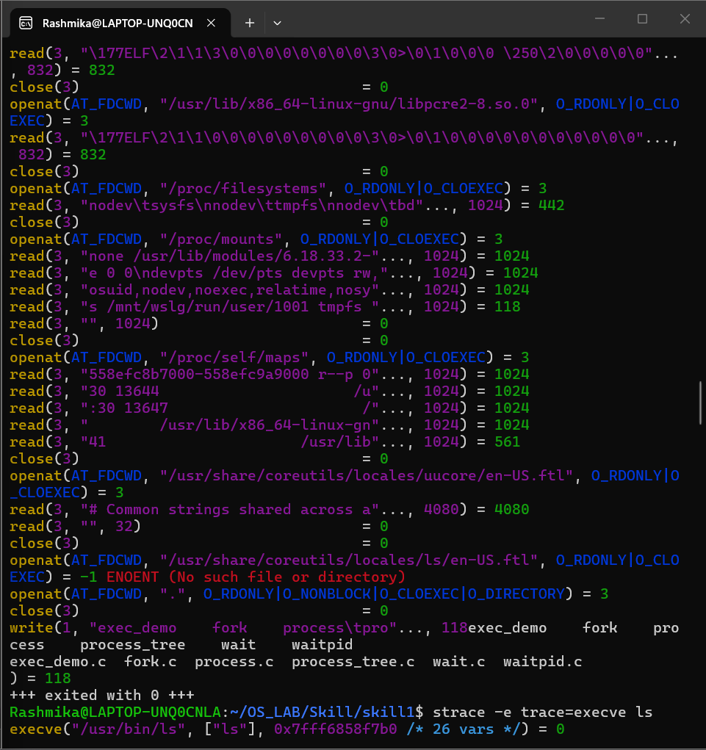
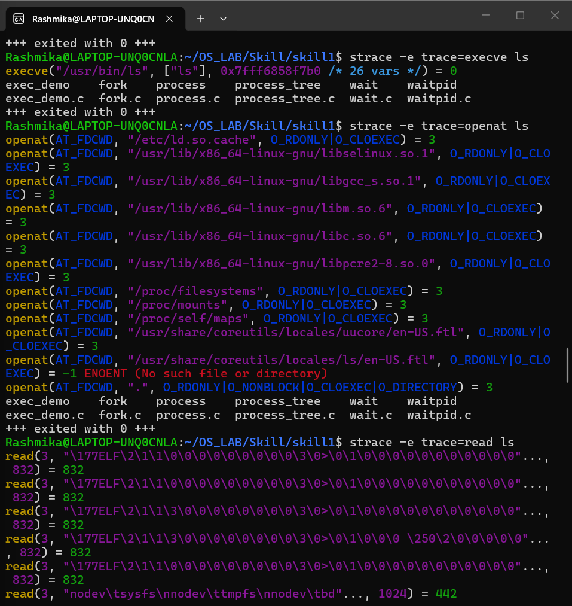
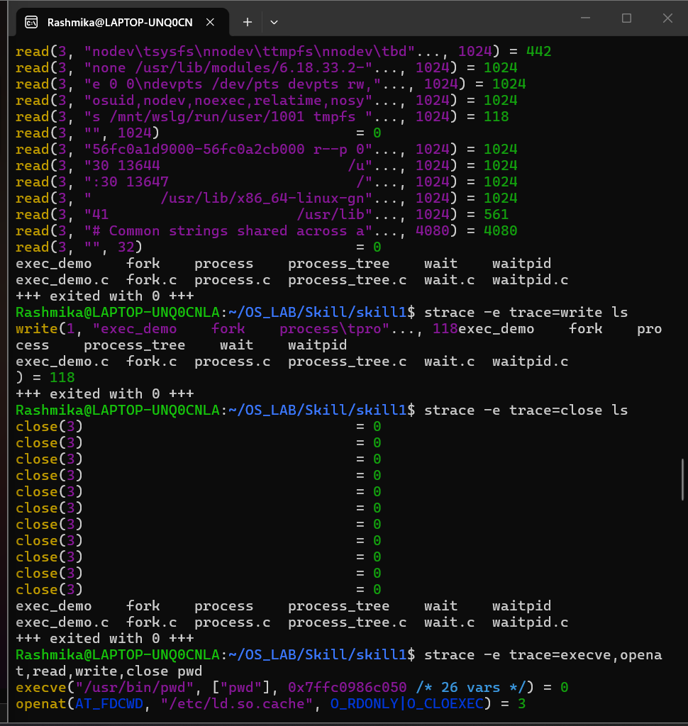
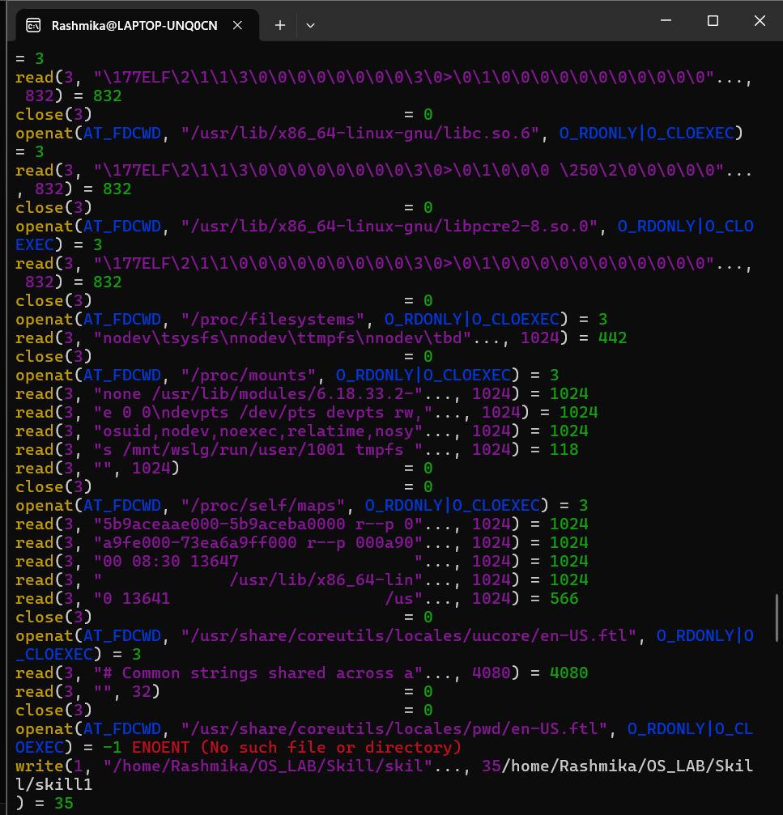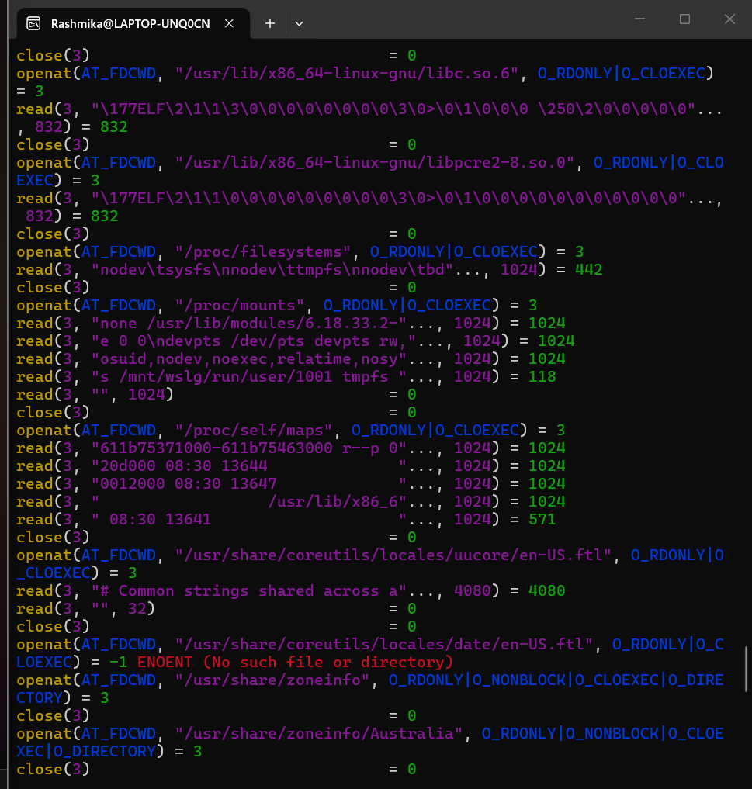
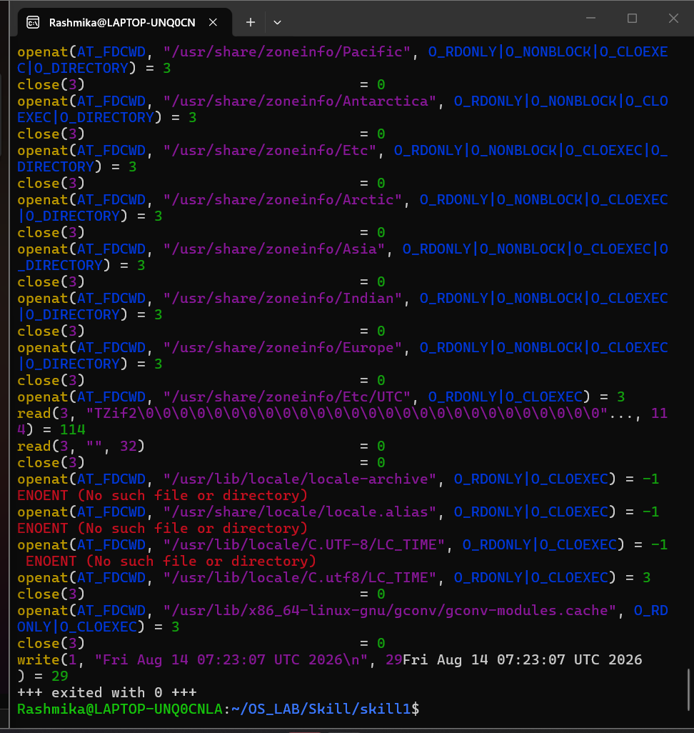

10. Mini Shell Program - Accept a command from the user, use fork(), exec(), and wait() to execute it, displaying parent and child PIDs

#include <stdio.h>
#include <stdlib.h>
#include <unistd.h>
#include <sys/wait.h>
#include <string.h>

int main() {
char command[100];

printf("Mini Shell\n");
printf("Enter command: ");
fgets(command, sizeof(command), stdin);

command[strcspn(command, "\n")] = '\0';

pid_t pid = fork();

if (pid < 0) {
perror("fork failed");
return 1;
}

if (pid == 0) {
printf("Child PID: %d\n", getpid());
printf("Parent PID: %d\n", getppid());

execlp(command, command, (char *)NULL);

perror("exec failed");
exit(1);
}
else {
printf("Parent PID: %d\n", getpid());
printf("Waiting for child...\n");

wait(NULL);

printf("Child process completed.\n");
}

return 0;
}

Output:
